|  |  |
| --- | --- |
| Semester | T.E. Semester VI – Computer Engineering |
| Subject | Cryptography and cyber security |
| Subject Professor In-charge | Prof. Amit Nerurkar |
| Assisting Teachers | Prof. Amit Nerurkar |
| Laboratory | M312B |

|  |  |
| --- | --- |
| Student Name | Deep Salunkhe |
| Roll Number | 21102A0014 |
| TE Division | A |

**Title: Design and Implementation of Monoalphabetic Cipher**



**Explanation:**

A monoalphabetic substitution cipher is a simple form of encryption where each letter in the plaintext is replaced by a corresponding letter in the ciphertext according to a fixed substitution scheme. In other words, each letter is consistently replaced by another letter throughout the message.

Breaking a monoalphabetic substitution cipher involves identifying the substitution key or pattern used to encrypt the message so that it can be decrypted. Here's a general approach to breaking such a cipher:

1. Frequency Analysis: Since the encryption scheme replaces each letter with another letter, the frequency of letters in the ciphertext should roughly correspond to the frequency of letters in the plaintext language. For instance, in English, 'E' is the most common letter, followed by 'T', 'A', and so on. By analyzing the frequency of letters in the ciphertext, one can make educated guesses about the substitutions.

2. Single-Letter Words: In English, the most common single-letter word is 'I'. If a single-letter word appears frequently in the ciphertext, it's likely to correspond to 'I' in the plaintext. Similarly, if a three-letter word appears, it's often 'THE'. Using such patterns can help deduce some letters.

3. Pattern Recognition: Look for recurring patterns of letters in the ciphertext, which may correspond to common words, prefixes, or suffixes in the plaintext. For example, 'TH', 'ING', 'TION', etc., are common patterns in English.

4. Contextual Analysis: If part of the message is known or can be guessed, it can provide clues about the substitutions. For instance, if the encrypted message is likely to contain certain common words or phrases (like "Dear," "Sincerely," etc.), identifying these can help determine their corresponding ciphertext letters.

5. Trial and Error: Use a combination of the above techniques to make educated guesses about the substitutions. You can start with the most frequently occurring letters and work your way down. As more letters are decrypted, it becomes easier to decipher the rest of the message.

6. Iterative Refinement: As more letters are decrypted, refine the substitutions and reanalyze the ciphertext for additional patterns and clues. This iterative process continues until the entire message is decrypted.

7. Manual or Automated Methods: Breaking a monoalphabetic substitution cipher can be done manually or with the help of computer algorithms. Automated methods can significantly speed up the process, especially for longer messages.



**Simulation:**

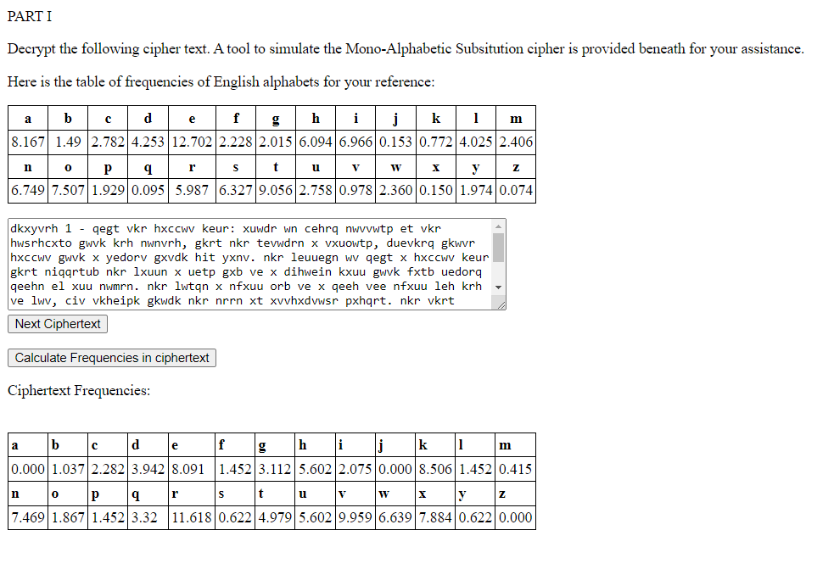

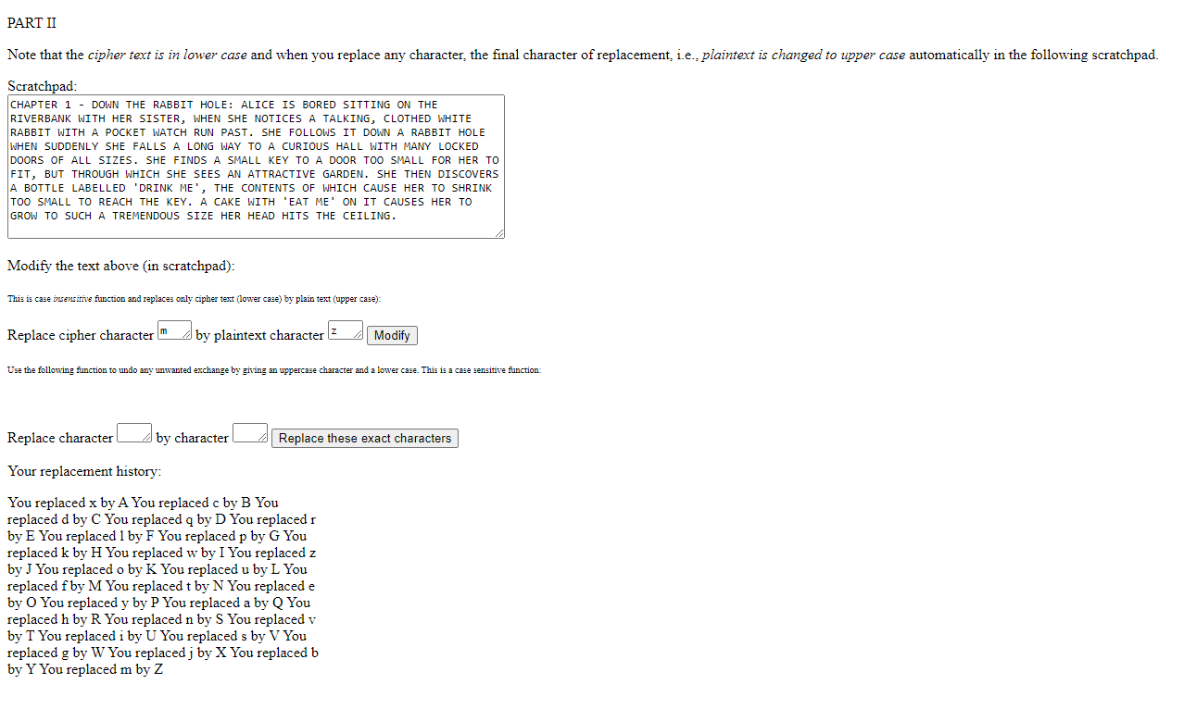

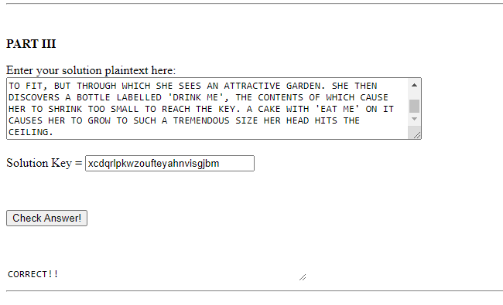

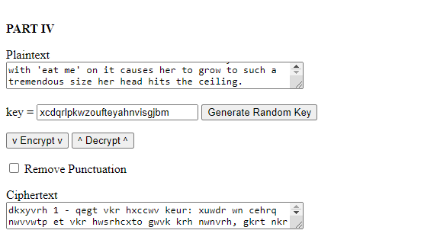



**Conclusion:**

In conclusion, breaking a monoalphabetic substitution cipher involves analyzing the frequency, patterns, and context of the ciphertext to deduce the substitutions used in the encryption. By employing techniques such as frequency analysis, identifying single-letter words, recognizing patterns, considering contextual clues, and employing trial and error, it's possible to decrypt the message. This process may require manual effort or the use of automated methods, depending on the complexity of the cipher and the available resources. Ultimately, with patience, persistence, and careful analysis, the encryption key or pattern can be determined, allowing for the decryption of the message.